WCBA Café Bridge @ Devizes
Wednesday 30th April 2025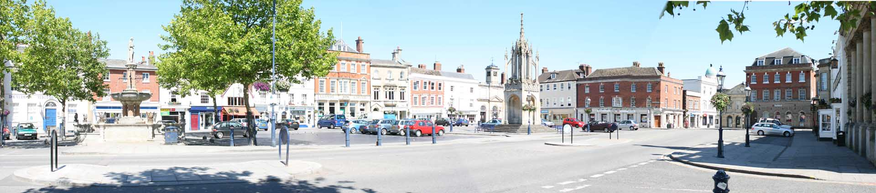
Wiltshire Café Bridge is back!
What is Café Bridge ?
Playing duplicate bridge in different locations, cafes, inns or restaurants.
The day starts with assembly at one venue, to register and collect your movement card, decide your lunch venue (first-come) and have a welcome coffee/tea. You then move to your start café. You play a number of boards in that café, then move on to another. Both NS and EW pairs move, and the cards are stationary. At some point, you break for lunch. This is included in the subscription for the day. You then move on to the next venue, and so on.
After play, we all meet up at one of the venues for a drink (included) and results and prizes.
Arrive at 10am and finish approx. 4.30pm. Venues include The Black Swan, Condado Lounge and The Bear Inn, all on Devizes Market Place, which is level and fairly easy access. Full details will be provided.
If you don’t have a partner, we can match up singletons.
Any questions and to register please email Phil Meats: phil@drmeats.net
(Or register on the WCBA website, Select Café Bridge in left menu)
Please provide a mobile number.
Cost is £40pp, by payable to Wiltshire Bridge Association
Sort code: 52-30-27 Acc. No: 35527234
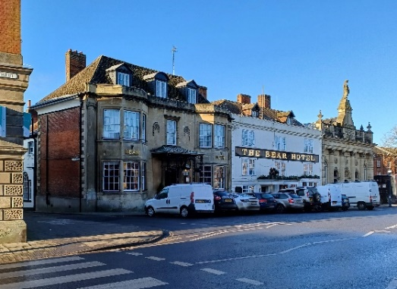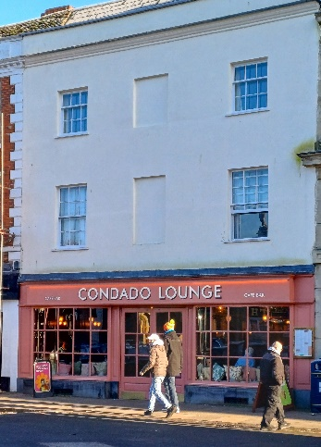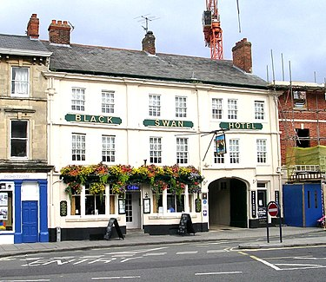
Entry Form WCBA Café Bridge @ Devizes
Wednesday 30th April 2024 10am to 4.30pm
First Name
Surname
Email
Contact phone (needed on the day)
Name of partner

Are you happy to use your smart phone to score?

Please use ‘Café’ and Name and EBU No as reference in BACs.

